**Introduction**

As feminism continues to become a pressing topic in North America, so does the argument surrounding gender wage gaps. Many argue that there is a gap in wages between men and women in a multitude of professional fields. One field that sparks the interest of researchers is higher education where the common notion is that male University professors are being paid more than their female counterparts. In this study, we will take a close look at Canadian Universities to answer the important question: Are male instructors being paid significantly more than female instructors on average at Canadian universities? Specifically (1) is the mean of the average salaries of male instructors higher than that of female instructors and (2) is the difference between the means significant?

**Methods**

The data used for this study was collected from StatsCanada (primary source). It contains the average salaries of instructors at 85 Canadian Universities, recorded for the 2017/18 and 2018/19 school years respectively. To evaluate whether there is a gender difference in average salaries, we need to use a statistical test that can compare the means of average salaries across all genders. The most appropriate statistical test that meets this condition is a one-way ANOVA. The rationale behind using a one-way ANOVA rather than a two-sample t-test is that there are more than 2 levels for the independent variable (gender). Additionally, as we are looking at the difference in means, we need a statistical test that can find provide information about the differences between the means of multiple groups. In terms of the characteristics of the data, variances of the populations are equal, the response variable residuals are normally distributed and the responses are independent and identically distributed normal random variables. Thus, all of the assumptions for the one-way ANOVA are met. In this study, the null hypothesis is H0: 𝜇male = 𝜇female while the alternative hypothesis is HA: 𝜇male > 𝜇female where “𝜇male” is the mean of the average salaries of male instructors in Canada and “𝜇female” is the mean of the average salaries of female instructors in Canada.

**Results**

To visualize the difference in salaries between genders, a boxplot was generated (Figure 1). No outliers were found in the boxplot (Figure 1). While examining the boxplot, relative to other genders, males were found to have the highest mean for the average salaries (Figure 1; 𝜇male=~$136163). One-way ANOVA was then performed to compare the means across the genders and, subsequently, they were found to be significantly different from each other (Figure 2; p=1.164e-06). Upon ANOVA post hoc analysis (Tukey multiple comparisons of means), the mean for male salaries was found to be significantly higher than the mean for female salaries (Figure 2; 𝜇diff=~$11187, p=0.0000005).

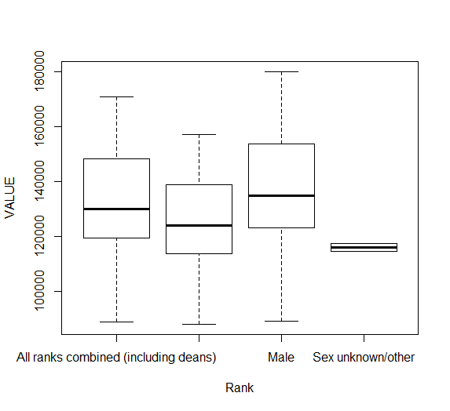

**Figure 1:** The figure above is a boxplot of the average salaries of instructors in Canada at Universities for all ranks combined (including deans) females, males, and sex unknown/other. Males showed the highest mean for average salaries amongst the other categories (𝜇male=~$136163).

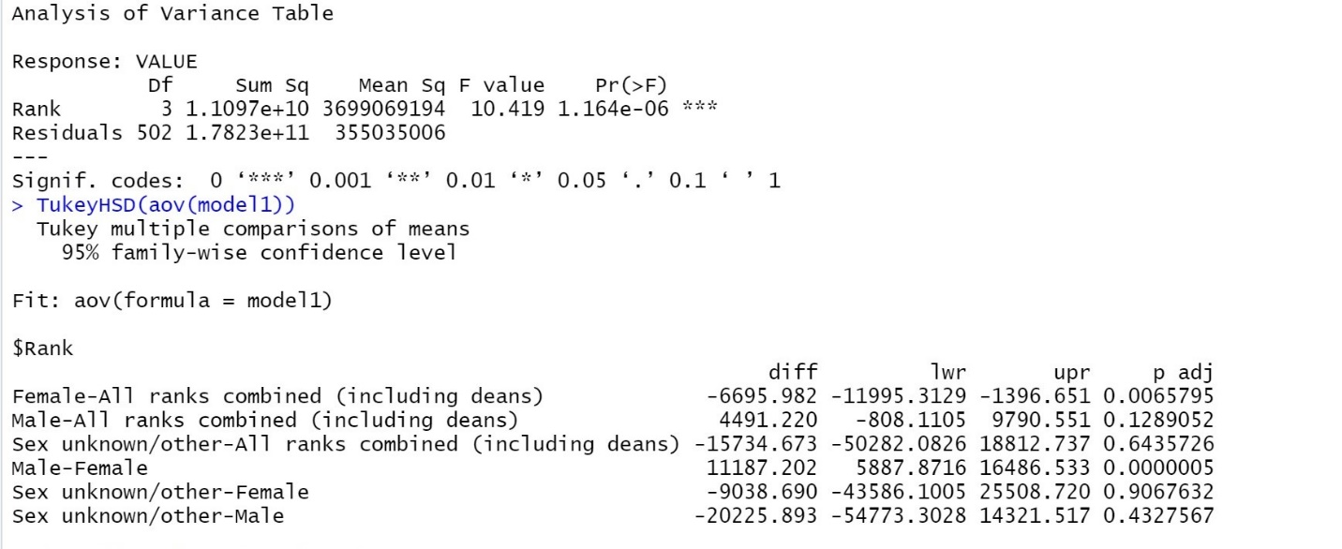

**Figure 2:** The figure above shows the results from a one-way ANOVA (p=1.164e-06). When comparing male instructor salaries and female instructor salaries, a significant difference was found (p=0.0000005) where males were being paid approximately $11187 more than females.

**Discussion**

In conclusion, at Canadian Universities, male instructors were found to be paid significantly more (on average) than female instructors. These results support the hypothesis that there is indeed a gender wage gap in this profession where men are receiving higher salaries. A limitation of this study was that only data from Universities with more than 100 staff were included. Additionally, there was the risk of confirmation bias towards to idea that male instructors are being paid more than female instructors. Despite these issues, the methods of analysis (i.e. experimental design) used in this study can provide a strong foundation for future research on gender wage gaps in other professions. Researchers can also perform random selection at the Universities where the original data was collected from and see if there are any significant differences to that of the original data.